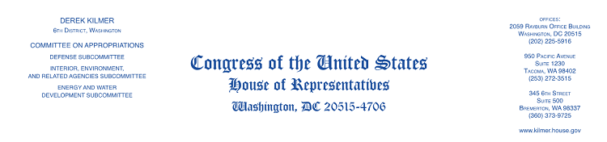

September 13, 2022

Rear Admiral Ann C. Phillips, US Navy (Ret.)
U.S. Department of Transportation
U.S. Maritime Administration
1200 New Jersey AVE SE
Washington, D.C. 20590

Dear Rear Admiral Phillips,

For years, the mutually dependent relationship between farmers in the Midwest and port infrastructure in the Pacific Northwest has resulted in substantial economic growth and greater food security across the region. That is why, I, alongside the undersigned group of Senators and Representatives, am pleased to write in support of the Port of Grays Harbor’s proposal for the Port Infrastructure Development Grant.

AGP’s plan to expand and enhance its export terminal at the Port of Grays Harbor in Aberdeen, Washington, will ultimately allow the facility to increase soybean meal exports from 3 million to 6 million metric tons. To accommodate this investment, the Port of Grays Harbor will expand its rail infrastructure within the complex to efficiently handle the increased volume, as well as mitigate the surface traffic impact to the local community. This will benefit U.S. soybean farmers across the Midwest, while also enhancing the economic vitality of the Port of Grays Harbor and the Aberdeen community.

Given the profound benefit this planned investment will provide to a significant number U.S. soybean farmers, the Iowa Soybean Association, the Kansas Soybean Commission, the Nebraska Soybean Board, the North Dakota Soybean Council, the South Dakota Soybean Research and Promotion Council, and the Soy Transportation Coalition have committed $900,000 to help underwrite some of the pre-engineering, design, and site development costs of the Port of Grays Harbor Terminal 4 Expansion and Development Project. These farmer organizations are not only expressing support for this worthwhile project, but they are also willing to invest significant resources to help make it a reality.

This single investment will simultaneously contribute to two significant national objectives – increasing global food security and environmentally sustainable energy. Largely inspired by the demand for soybean oil as one of the primary feedstocks for the expanding renewable energy market, a significant amount of additional soybean processing has been announced throughout the country.

We are pleased to partner in this effort to promote this important infrastructure project, and urge your full and fair consideration of their proposal. Should you have any questions, please contact Emma Abraham in my Tacoma Office at (253) 272-3515 or Emma.Abraham@mail.house.gov.

Sincerely,
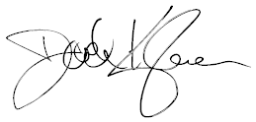
Derek Kilmer
Member of Congress

